

PROJECT TITLE

A CAPSTONE PROJECT REPORT

A Capstone Project Report submitted in partial fulfilment of the requirements for the Course of

CSA0904 PROGRAMMING IN JAVA
to the award of the degree of

BACHELOR OF TECHNOLOGY IN INFORMATION TECHNOLOGY

Submitted by
MOHAN RAJ V D (192424151)
MONESH S (192324027)
DHARSHAN A N (192525370)
SELVA PRABHU A K (192421244)
GANESH P (192421142)

Under the Supervision of
Dr.R.ThalapathiRajasekaran
SIMATS ENGINEERING
Saveetha Institute of Medical and Technical Sciences Chennai-602105
SEPTEMBER 2026

SIMATS ENGiNEERING
Saveetha Institute of Medical and Technical Sciences Chennai-602105

BONAFIDE CERTIFICATE

This is to certify that the Capstone Project entitled “AgriSphere AI – Intelligent Digital Agriculture Ecosystem” has been carried out by Ganesh P(192421142) under the supervision of
Dr.R.Thalapathi Rajasekaran and is submitted in partial fulfilment of the requirements for the current semester of the B.Tech Information Technology program at Saveetha Institute of Medical and Technical Sciences, Chennai.

COURSE COORDINATOR COURSE FACULTY
Dr.G.Charlyn Pushpa Latha Dr.R.Thalapathi Rajasekaran
Professor Professor
Department of CSE Department of CSE
SIMATS Engineering, SIMATS Engineering,
SIMATS, Chennai – 602105. SIMATS, Chennai – 602105.

SIMATS ENGINEERING
Saveetha Institute of Medical and Technical Sciences
Chennai-602105

DECLARATION
I Ganesh P of the B.Tech Information Technology, SIMATS Engineering, Saveetha Institute of Medical and Technical Sciences, Chennai, hereby declare that the Capstone Project Work entitled “[is the result of our own bonafide efforts. To the best of our knowledge, the work presented herein is original, accurate, and has been carried out in accordance with the principles of engineering ethics and academic integrity. All sources, references, data, and other materials used in the project have been appropriately acknowledged. We further declare that the data, results, analysis, and findings presented in this report have not been fabricated, falsified, or manipulated. Any external tools, software, datasets, computational resources, or AI-assisted tools used during the project have been appropriately disclosed. We confirm that all applicable ethical, academic, institutional, and professional requirements have been duly followed throughout the planning, execution, analysis, and documentation of the project.

Place:
Date:

Signature of the Students with Names

SIMATS ENGINEERING
Saveetha Institute of Medical and Technical Sciences
Chennai-602105

INDIVIDUAL CONTRIBUTION STATEMENT

Student Name / Register No. | Specific Responsibilities | Design & Development | Testing & Analysis | Report Contribution | Approx. Contribution (%)
MOHAN RAJ V D 192424151 | Overall project coordination and AI recommendation module planning | Designed overall system architecture and recommendation workflow | Verified integration between AI recommendation and marketplace | Module 4 | 20%
MONESH S 192324027 | User preference and profile data handling | Developed user-preference and browsing-behaviour processing | Tested user inputs and recommendation conditions | Module 5 | 20%
DHARSHAN A N 192525370 | AI recommendation logic and product matching | Developed the personalized recommendation logic based on user interactions | Tested recommendation outputs for different user preferences | Module 2 | 20%
SELVA PRABHU A K 192421244 | Marketplace and product-data integration | Integrated agricultural product information with the recommendation engine | Tested product discovery and recommendation integration | Module 1 | 20%
GANESH P 192421142 | Documentation, analysis and overall module validation | Integrated agricultural product information with the recommendation engine | Performed functional testing and analyzed system outputs | Module 3 | 20%
Total |  |  |  |  | 100%

ABSTRACT
AgriSphere AI is presented as an intelligent digital agriculture ecosystem intended to connect farmers, buyers, service providers, and administrators on a centralized platform. Within this ecosystem, Module 3, the AI Recommendation Engine, focuses on personalized recommendation and advisory functions. The module uses user preferences and browsing behaviour to understand buyer interests and generate relevant agricultural product recommendations, thereby reducing the effort required to search through the marketplace. The project presentation further demonstrates an advisory-oriented interface in which farm parameters such as soil classification, soil pH, active or planned crop, growth stage, season, and acreage are used to present crop and soil-health recommendations.
The engineering problem addressed by this module is the difficulty of converting marketplace and user-interaction information into useful, personalized guidance. The proposed solution integrates recommendation intelligence directly with marketplace information rather than treating AI as an isolated feature. The overall system architecture presented in the project uses a Next.js frontend, Node.js with Express.js backend, MongoDB database, and external services including Nodemailer, Cloudinary, Firebase, and Razorpay. For Module 3, the architecture establishes a data path through which user and marketplace information can support recommendation generation.
The project presentation identifies personalized product discovery, AI-based recommendations, and improved customer experience as the principal intended outcomes. It also identifies future enhancement through larger agricultural datasets, advanced AI recommendations, real-time market data, predictive analytics, and IoT integration. The supplied PPT does not provide numerical accuracy measurements, a named recommendation algorithm, training dataset, or source-code listing; therefore, these are recorded as implementation details requiring further validation rather than claimed experimental results.
Keywords: AgriSphere AI, AI Recommendation Engine, Digital Agriculture, Personalized Recommendation, Crop Advisory, Marketplace

TABLE OF CONTENTS

Sl. No. | Title | Page No.
i | CERTIFICATE FROM THE SUPERVISOR | ii
ii | DECLARATION BY THE CANDIDATE | iii
iii | INDIVIDUAL CONTRIBUTION STATEMENT | iv
iv | ABSTRACT | v
v | LIST OF FIGURES | vi
vi | LIST OF TABLES | vii
vii | LIST OF ABBREVIATIONS | viii
1 | CHAPTER 1: Introduction and Engineering Problem | 1
2 | CHAPTER 2: Literature Review and Existing Solutions | 4
3 | CHAPTER 3: Engineering Design & Trade-offs, Sustainability, Ethics, Safety, Risk & Security | 7
4 | CHAPTER 4: Implementation, Testing & Results, Project Management | 12
5 | CHAPTER 5: Conclusion, Future Work and Reflection | 17
 | References | 20
 | Appendices | 21

LIST OF FIGURES

Figure No. | Figure Name | Page No.
Figure 3.1 | AgriSphere AI system architecture and system flow | 9
Figure 4.1 | Module 3 AI Crop & Soil Health Advisory Hub – sample output | 13

LIST OF TABLES

Table No. | Table Name | Page No.
Table 1.1 | Project objectives for Module 3 | 3
Table 2.1 | Review of existing approaches | 5
Table 2.2 | Comparative analysis | 6
Table 3.1 | Stakeholder requirements | 7
Table 3.2 | Functional and non-functional requirements | 8
Table 3.3 | Design specifications | 8
Table 3.4 | Alternative solution evaluation | 9
Table 3.5 | Trade-off analysis | 10
Table 3.6 | Sustainability, ethics, safety and security | 11
Table 3.7 | Risk register | 11
Table 4.1 | Implementation resources | 12
Table 4.2 | Test plan and verification | 14
Table 4.3 | Objective achievement | 16
Table 4.4 | Project planning and budget | 16

LIST OF ABBREVIATIONS / SYMBOLS

Symbol | Description | Unit
AI | Artificial Intelligence | –
UI | User Interface | –
API | Application Programming Interface | –
HTTPS | Hypertext Transfer Protocol Secure | –
JWT | JSON Web Token | –
IoT | Internet of Things | –
pH | Potential of Hydrogen | pH scale
REST | Representational State Transfer | –

CHAPTER 1

INTRODUCTION AND ENGINEERING PROBLEM

1.1 Background
Agriculture increasingly requires digital mechanisms that can connect producers, customers, and agricultural service providers while reducing the limitations of conventional buying and selling. The project PPT presents AgriSphere AI as a centralized intelligent digital agriculture ecosystem. It is designed to connect farmers, buyers, service providers, and administrators, while providing product management, marketplace functions, AI recommendations, notifications, and analytics.
Module 3 is the AI Recommendation Engine. The PPT describes it as a module that uses user preferences and browsing behaviour to understand the interests of buyers and generate personalized agricultural product recommendations. The module is therefore positioned at the intersection of marketplace data, user interaction, and AI-based decision support.

1.2 Need for the Project
- Farmers can have difficulty finding genuine buyers and obtaining fair prices for agricultural products.
- Buyers may find it difficult to identify trusted farmers and relevant agricultural products.
- Traditional search through a large product marketplace can require unnecessary user effort.
- The project identifies limited access to AI-based recommendations and real-time market insights as an existing challenge.
- A recommendation layer can improve product discovery by presenting information according to user preferences and interactions.

1.3 Problem Statement
The engineering problem is to design an AI-enabled recommendation function within a centralized digital agriculture marketplace that can use available user preferences and browsing behaviour to identify relevant agricultural products and advisory information. The solution must integrate with marketplace information, support useful product discovery, and remain extensible to future agricultural data sources, while operating within the technical and data limitations stated or implied by the project architecture.

1.4 Project Aim
To design and document Module 3 of AgriSphere AI as an AI Recommendation Engine that provides personalized agricultural product recommendations and advisory information by using user preferences, interaction behaviour, and relevant agricultural parameters.

1.5 Project Objectives
- Design the recommendation-engine role within the AgriSphere AI ecosystem.
- Use user preferences and browsing behaviour as inputs for personalized recommendations.
- Integrate AI recommendation capability with marketplace information for improved product discovery.
- Demonstrate an advisory interface using agricultural parameters such as soil type, pH, crop, growth stage, season, and acreage.
- Evaluate the intended module behaviour through defined functional tests and document limitations and future improvements.

Objective | Measurable/Verifiable Evidence
O1 | Recommendation function linked to user/product information
O2 | Personalized recommendations generated from defined inputs
O3 | Recommendation capability integrated with marketplace concept
O4 | Advisory interface accepts agricultural parameters
O5 | Defined verification cases and documented limitations

1.6 Scope
Included: personalized agricultural product recommendations, use of user preferences and browsing behaviour, integration with marketplace information, and advisory-oriented recommendation display. The project PPT also demonstrates farm parameters and crop/soil recommendations in the Module 3 sample output.
Excluded or not specified in the PPT: the exact machine-learning algorithm, training dataset, model-training procedure, model accuracy, production-scale latency, detailed source code, and quantified user-study results. These items should be supplied separately if available.

1.7 Expected Engineering Outcome
The intended outcome is a functional AI recommendation component within AgriSphere AI that improves product discovery and provides personalized agricultural guidance. At the prototype level, the expected interface is an AI advisory hub that accepts agricultural inputs and presents a recommendation with an explanation and action-oriented information.

CHAPTER 2

LITERATURE REVIEW AND EXISTING SOLUTIONS

2.1 Review Method
The literature review is based on the four existing approaches explicitly listed in the project PPT. The review compares their stated focus and limitations with the proposed AgriSphere AI concept. The source presentation does not provide journal names, volume/issue details, DOI information, or URLs, so no additional bibliographic details are introduced here.

2.2 Review of Existing Work
The PPT identifies four relevant directions: IoT and cloud-based farm monitoring; AI-based crop recommendation and yield prediction; online agricultural marketplaces; and digital farming platforms using precision agriculture. These approaches address individual parts of the agricultural digitalisation problem, whereas AgriSphere AI is presented as an integrated ecosystem.

S. No. | Literature / Existing Approach | Author & Year | Limitation stated in PPT | Relevance to Module 3
1 | Smart Agriculture Monitoring Using IoT and Cloud Computing | Patel & Singh, 2022 | Focuses on monitoring and sensor data without an online marketplace. | Shows value of agricultural data; future input source for recommendations.
2 | AI-Based Crop Recommendation and Yield Prediction System | Kumar et al., 2023 | Provides crop recommendations but not product selling or business management. | Supports AI recommendation concept; AgriSphere links it to marketplace context.
3 | Online Agricultural Marketplace for Farmers | Sharma & Verma, 2021 | Supports online selling but lacks AI recommendations and service integration. | Provides marketplace data that can feed recommendation functions.
4 | Digital Farming Platform with Precision Agriculture | Das & Roy, 2024 | Concentrates on precision farming without connecting buyers and agricultural services. | Demonstrates broader digital-farming context for future recommendation expansion.

2.3 Comparative Analysis

Existing Approach | Advantages | Limitations | Relevance to Proposed Work
IoT + Cloud Monitoring | Can collect farm/sensor information | No marketplace in the stated approach | Future data source for richer recommendations
AI Crop Recommendation | AI-driven agricultural guidance | Limited business/marketplace integration | Supports the AI recommendation layer
Online Marketplace | Direct product selling and discovery | No stated AI personalization | Core environment in which Module 3 operates
Precision Agriculture Platform | Digital farm-management focus | Does not connect all ecosystem stakeholders | Future integration opportunity

2.4 Research / Engineering Gap
The gap identified from the PPT is the lack of a single ecosystem that combines agricultural marketplace functions with personalized AI recommendations and broader stakeholder services. For Module 3 specifically, the unresolved engineering requirement is to connect recommendation intelligence to actual user interaction and marketplace information so that AI directly improves product discovery and customer experience.

2.5 Proposed Contribution
The proposed contribution is an integrated recommendation layer rather than a standalone crop-recommendation application. The module uses user preferences and browsing behaviour for personalization and is presented as part of a larger ecosystem containing marketplace, services, order management, and analytics. The Module 3 sample interface additionally demonstrates an agronomic advisory use case using farm parameters.

CHAPTER 3

ENGINEERING DESIGN & TRADE-OFFS, SUSTAINABILITY, ETHICS, SAFETY, RISK & SECURITY

3.1 Requirements
The following requirements translate the Module 3 description in the PPT into verifiable engineering requirements. Where the PPT gives no numerical target, the target is expressed as a functional acceptance condition rather than as a fabricated numerical performance claim.
Stakeholder | Requirement
Buyer / User | Receive recommendations relevant to preferences and browsing behaviour.
Farmer | Benefit from improved product visibility and relevant agricultural guidance.
Administrator | Maintain a reliable recommendation-enabled ecosystem.
System / Platform | Connect recommendation capability with marketplace data and user interactions.

Requirement | Type | Measurable Target
Personalized recommendation | Functional | Output changes appropriately when relevant user/product inputs change.
User interaction input | Functional | Preferences and browsing behaviour are available as recommendation inputs.
Marketplace integration | Functional | Recommendation output is presented in the marketplace/advisory context.
Agricultural advisory inputs | Functional | Prototype accepts soil type, pH, crop, growth stage, season and acreage.
Explainable output | Non-Functional | Recommendation includes understandable supporting text/action guidance.
Extensibility | Non-Functional | Design permits future market, IoT and analytics data integration.

3.2 Constraints & Applicable Standards
The PPT explicitly identifies a web architecture using HTTPS between frontend and backend and JWT-based authentication in the backend. It does not identify formal standards or regulatory codes. Accordingly, no unsupported standards are claimed as implemented. The security-related design requirements below are derived only from the architecture shown in the PPT.
Standard / Code | Requirement | How Applied in This Project
HTTPS | Secure communication between frontend and backend | Shown in the system architecture between Next.js frontend and Node.js/Express backend.
JWT | Token-based authentication mechanism | Listed under backend authentication in the PPT architecture.
RESTful API | Structured frontend-backend interaction | Listed as a backend capability and used for API calls.

3.3 Design Specifications
Parameter | Target / Requirement | Unit | Priority
Recommendation relevance | Relevant to user preference / interaction | Qualitative | High
Input responsiveness | Recommendation generated from available inputs | Qualitative | High
Agricultural inputs | Soil type, pH, crop, growth stage, season, acreage | Mixed | High
Marketplace integration | Recommendations linked to product discovery | Qualitative | High
Security | Protected access to user-related information | Qualitative | High
Extensibility | Support future AI/IoT/market data inputs | Qualitative | Medium

3.4 Alternative Solutions & Evaluation
Alternative 1: Rule-based recommendation can use predefined agricultural relationships and is simple to explain, but it may be less adaptive to user behaviour. Alternative 2: A user-behaviour-driven recommendation approach uses preferences and browsing behaviour and aligns directly with the Module 3 description. Alternative 3: A hybrid approach can combine behavioural personalization with agronomic rules and future agricultural datasets; it offers extensibility but requires more design and validation.
Criterion | Weight | Alternative 1  Rule-based | Alternative 2  Behaviour-based | Alternative 3  Hybrid
Personalization | High | Medium | High | High
Explainability | High | High | Medium | High
Implementation simplicity | Medium | High | Medium | Low
Agricultural advisory potential | High | High | Medium | High
Future extensibility | Medium | Medium | High | High
Overall suitability | — | Good | Very Good | Very Good

3.5 Selected Design & Detailed Design
The selected design is a marketplace-integrated recommendation engine with personalized inputs and an advisory-oriented presentation. This choice follows the PPT requirement that Module 3 use user preferences and browsing behaviour while also integrating AI with marketplace data. The sample output further demonstrates an advisory interface that processes soil and crop parameters.
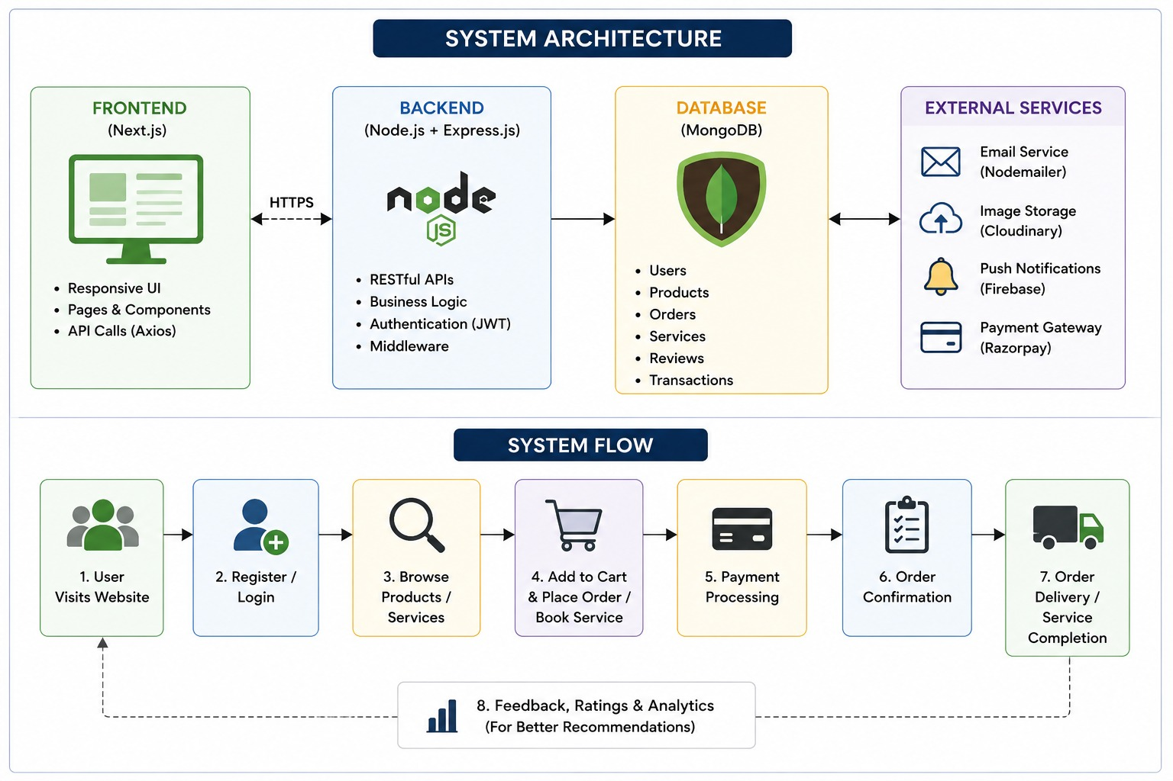
Figure 3.1: AgriSphere AI system architecture and system flow (from the project PPT).
The architecture shows a Next.js frontend communicating through HTTPS with a Node.js + Express.js backend. The backend provides RESTful APIs, business logic, JWT authentication and middleware. MongoDB stores users, products, orders, services, reviews and transactions. External services include Nodemailer, Cloudinary, Firebase and Razorpay. The system flow moves from user access and registration through browsing, cart/order or service booking, payment, confirmation, delivery/completion, and feedback/analytics; the latter is explicitly linked to better recommendations in the architecture.
For Module 3, the recommendation subsystem conceptually receives user preferences and interaction information from the application layer, accesses relevant marketplace/agricultural information, generates personalized recommendations, and returns an understandable recommendation to the interface. The PPT does not specify the exact model or algorithm, so the detailed computational method remains an implementation item for future source-code documentation.

3.6 Trade-off Analysis

Design Decision | Alternative Considered | Benefit | Disadvantage | Final Decision & Justification
Personalized recommendations | Generic product listing | Improves discovery | Requires user data | Selected because personalization is a stated Module 3 function.
Integrated marketplace AI | Standalone AI advisory | Directly supports product discovery | Tighter coupling with marketplace data | Selected because PPT explicitly states integration with marketplace.
Advisory-style output | Plain recommendation list | More understandable and actionable | Needs richer domain rules/data | Selected for prototype because Module 3 sample output demonstrates advisory guidance.
Extensible data design | Fixed recommendation inputs | Supports future IoT/market data | More design effort | Selected because future scope includes IoT, live market data and advanced AI.

3.7 Sustainability, Ethics, Safety, Risk & Security

Domain | Consideration | Evidence Evaluated | Impact on Final Decision
Sustainability | Digital product discovery and future smart agriculture | PPT states digital transformation and future IoT/AI expansion | Supports a centralized digital design with extensible modules.
Ethics | Recommendation should support rather than replace informed user decisions | PPT describes recommendations as support for decisions | Output is presented as advisory information, not as an unconditional command.
Health & Safety | Agricultural recommendations can influence farming activities | Sample output includes crop/soil advisory information | Recommendations should be validated before production use; no clinical/chemical safety claims are made.
Security | User preferences and interaction data require controlled access | Architecture lists JWT authentication and HTTPS | Security mechanisms are retained as core platform requirements.

Risk | Likelihood | Severity | Risk Level | Mitigation | Residual Risk
Irrelevant recommendation | Medium | Medium | Medium | Use relevant user/product inputs and feedback | Low–Medium
Insufficient agricultural data | Medium | High | High | Validate data sources and expand datasets | Medium
Privacy / unauthorized access | Medium | High | High | JWT, HTTPS and controlled access | Medium
Model/logic bias | Medium | Medium | Medium | Review recommendation rules/data and test diverse cases | Low–Medium
Incorrect advisory interpretation | Medium | High | High | Provide explanatory output and validation guidance | Medium

CHAPTER 4

IMPLEMENTATION, TESTING & RESULTS, PROJECT MANAGEMENT

4.1 Development Approach & Resources
The project presentation follows a modular system approach. AgriSphere AI is divided into five modules, with Module 3 dedicated to the AI Recommendation Engine. The recommendation module is designed to operate as part of the marketplace and broader platform rather than as a separate application. The PPT provides a system architecture and a Module 3 sample interface, which serve as the principal implementation evidence available for this report.
Resource / Technology | Purpose | Stage Used
Next.js | Frontend and responsive user interface | System architecture / interface
Node.js + Express.js | Backend, RESTful APIs and business logic | System architecture
MongoDB | Storage for platform data | System architecture
Axios | Frontend API calls | System architecture
JWT | Authentication | System architecture
Nodemailer | Email service | External service
Cloudinary | Image storage | External service
Firebase | Push notifications | External service
Razorpay | Payment gateway | External service

4.2 Hardware / Software / Fabrication Implementation & Modern Tools Used

Software Implementation
The supplied PPT identifies a web-based architecture rather than a hardware prototype. The frontend is shown as Next.js with responsive UI, pages/components and Axios API calls. The backend is Node.js with Express.js and includes RESTful APIs, business logic, JWT authentication and middleware. MongoDB is shown as the database. For Module 3, the interface is designed to expose AI advisory information within the platform navigation.
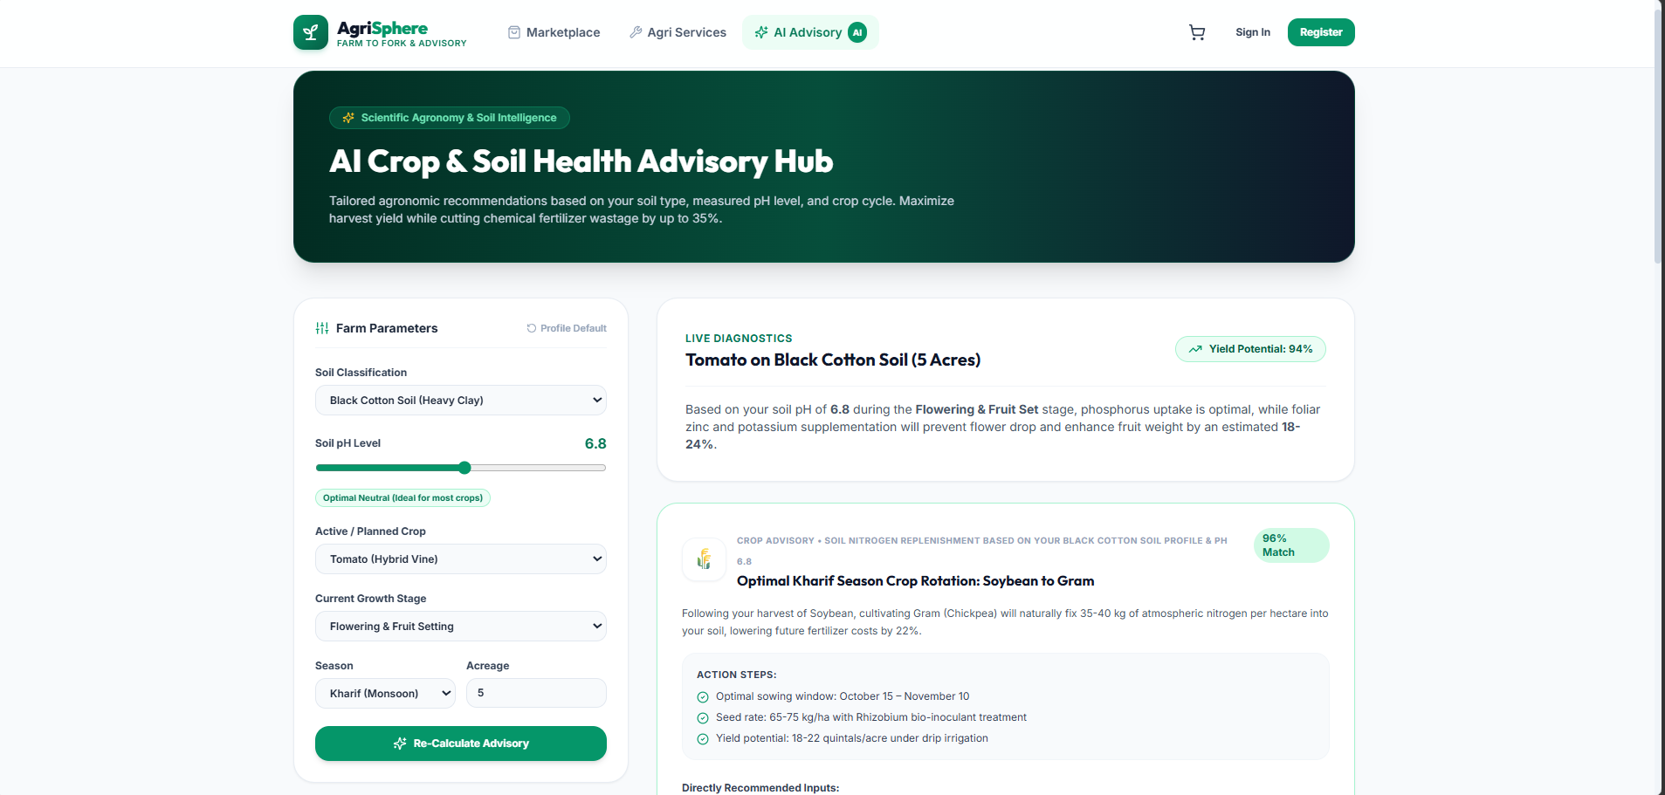
Figure 4.1: Module 3 – AI Crop & Soil Health Advisory Hub sample output shown in the project PPT.
The sample output provides visual evidence of an advisory workflow. It displays the soil classification as “Black Cotton Soil (Heavy Clay),” soil pH as 6.8, active/planned crop as “Tomato (Hybrid Vine),” current growth stage as “Flowering & Fruit Setting,” season as “Kharif (Monsoon),” and acreage as 5. The live diagnostics area presents an advisory for tomato on black cotton soil, while the crop advisory section presents a crop-rotation recommendation with action steps. These values are example interface content shown in the PPT and are not treated as experimentally measured outcomes.

4.3 Test Plan & Verification
Because the PPT does not contain a formal test log or measured accuracy data, the following verification plan is defined from the stated Module 3 functions. The status column is intentionally based on the evidence available in the PPT: “Demonstrated” means visible in the sample output or explicitly stated; “Not evidenced” means the PPT does not provide sufficient test evidence.
Requirement | Test Method | Acceptance Criterion | Specification | Required Value | Achieved Value | Status
Personalized recommendation | Check recommendation module description and sample workflow | Recommendation is generated from user/product-related inputs | Personalization | Input-dependent recommendation | Stated in PPT; UI demonstrates advisory inputs | Demonstrated conceptually
Agricultural input handling | Inspect Module 3 sample output | Soil, pH, crop, stage, season and acreage are represented | Input fields | Six input categories | Six categories visible | Demonstrated
Marketplace integration | Check module description | AI capability contributes to product discovery | Integration | Recommendation linked to marketplace | Explicitly stated | Demonstrated conceptually
Recommendation explanation | Inspect sample output | Output provides supporting explanation/action steps | Explainability | Readable guidance | Visible in sample output | Demonstrated
Algorithm accuracy | Review PPT for measured metrics | Quantified accuracy available | Accuracy | Measured metric | Not provided | Not evidenced
Source-code verification | Review project source code | Implementation matches report | Code | Source available | Not included in PPT | Not evidenced

4.4 Results
The principal available result is the Module 3 prototype/sample interface shown in Figure 4.1. It demonstrates an AI Crop & Soil Health Advisory Hub with farm-parameter inputs and generated advisory content. The PPT also states that the AI recommendation engine provides personalized product recommendations based on user preferences and interactions. No numerical accuracy, precision, recall, response time, recommendation click-through rate, or user-study results are supplied in the source presentation.
Result Area | Evidence in PPT | Engineering Interpretation
Personalization | Module 3 description | Recommendation is intended to adapt to preferences and browsing behaviour.
Advisory interface | Module 3 sample output | The prototype demonstrates a structured input-to-advice interaction.
Marketplace integration | Module 3 description | AI is positioned as part of product discovery rather than an isolated feature.
System integration | Architecture diagram | Frontend, backend, database and external services form the platform context.

4.5 Data Analysis & Engineering Judgment
The available evidence supports a qualitative engineering judgment that Module 3 extends the agricultural marketplace from simple search toward guided discovery and advisory interaction. The sample output also demonstrates that the interface can present multiple agricultural parameters together and return an explanatory recommendation. However, the project PPT does not provide a dataset, ground-truth labels, model-training details, benchmark results, or controlled user evaluation. Therefore, the current evidence supports prototype functionality and design intent, but not a quantitative claim of AI model accuracy or production readiness.

4.6 Comparison with Existing Solutions & Achievement of Objectives
Objective | Evidence | Achievement (Fully / Partially / Not Achieved)
Design recommendation-engine role | Module 3 definition and system architecture | Fully
Use preferences and browsing behaviour | Explicit Module 3 description | Fully at concept level
Integrate AI with marketplace | Explicit Module 3 description | Fully at concept level
Demonstrate agricultural advisory inputs | Module 3 sample output | Fully demonstrated in prototype UI
Quantitatively evaluate recommendation performance | No accuracy/test metrics in PPT | Not evidenced
Provide production implementation/source code | No source code in PPT | Not evidenced

4.7 Strengths & Limitations
Strengths:
- Integrates AI recommendation with the broader marketplace ecosystem.
- Uses user preferences and browsing behaviour for personalization.
- Prototype output presents understandable agricultural parameters and action-oriented recommendations.
- Architecture is modular and extensible to future AI, IoT and market-data capabilities.
- The module contributes directly to product discovery and customer experience.
Limitations:
- Exact recommendation algorithm is not specified in the PPT.
- Training or evaluation dataset is not provided.
- Quantitative recommendation accuracy and performance metrics are not available.
- The sample output alone does not establish correctness of agronomic recommendations in real-world farming conditions.
- Detailed implementation source code is not included in the supplied presentation.

4.8 Project Planning, Roles & Budget
The PPT does not provide a Gantt chart, task allocation, or component cost breakdown. To avoid inventing project-management evidence, the report records these as completion items for the team to fill from actual project records.
Student | Assigned Responsibility | Actual Contribution
MOHAN RAJ VD | To be filled from team record | To be filled
MONESH S | To be filled from team record | To be filled
DHARSHAN AN | To be filled from team record | To be filled
SELVA PRABHU AK | To be filled from team record | To be filled
GANESH P | To be filled from team record | To be filled

Item | Estimated Cost | Actual Cost
Software / development resources | To be filled | To be filled
Hosting / external services | To be filled | To be filled
Other project resources | To be filled | To be filled
Total | To be filled | To be filled

CHAPTER 5

CONCLUSION, FUTURE WORK AND REFLECTION

5.1 Conclusion
AgriSphere AI is presented as a centralized digital agriculture ecosystem connecting farmers, buyers, service providers, and administrators. Module 3, the AI Recommendation Engine, extends the marketplace by using user preferences and browsing behaviour to generate personalized recommendations. The project PPT also demonstrates a crop and soil advisory interface using soil classification, pH, crop, growth stage, season, and acreage as inputs. The system architecture shows how the recommendation function fits within a larger web platform consisting of a Next.js frontend, Node.js/Express backend, MongoDB database, and external services.
The available prototype evidence supports the intended functional role of Module 3 and demonstrates the advisory interface. At the same time, the supplied material does not establish quantitative AI performance, production-scale validation, or algorithmic accuracy. The principal contribution of the module is therefore its integrated recommendation concept and prototype-level demonstration within the AgriSphere AI ecosystem.

5.2 Future Work
- Integrate larger agricultural datasets to improve recommendation quality.
- Develop advanced AI recommendations for crops, products, farming activities and market decisions.
- Integrate real-time agricultural market data for current price and demand insights.
- Extend predictive analytics for sales, demand, product trends and business growth.
- Integrate IoT sensors for soil moisture, temperature, humidity and crop-condition data.
- Extend the platform to dedicated mobile applications for farmers, buyers and service providers.

5.3 Professional Learning & Individual Reflection
New Knowledge Acquired:
- Understanding of a modular digital-agriculture ecosystem and the role of an AI recommendation layer.
- Understanding of how frontend, backend, database and external services interact in a system architecture.
- Exposure to personalization using user preferences and browsing behaviour.
- Understanding of advisory-style presentation of agricultural inputs and recommendations.
Engineering & Professional Skills Developed:
- Requirement identification and module-level system design.
- Architecture interpretation and subsystem integration thinking.
- Technical documentation and comparison of existing approaches.
- Testing-plan formulation and evidence-based engineering judgment.

Individual Reflection – MOHAN RAJ VD
Module 4 – User & Profile Management helped me understand secure registration, login, user profiles, and role-based access control. The most difficult part was managing different permissions for farmers, buyers, service providers, and administrators. I learned how user management forms the foundation of the AgriSphere AI platform. This experience improved my programming, problem-solving, testing, and teamwork skills.

Individual Reflection – MONESH S
Working on Module 5 – Smart Digital Marketplace helped me understand how farmers can digitally list and sell agricultural products while buyers can search, compare, and purchase products. I learned about product management, marketplace integration, and user-friendly product discovery. The main challenge was organizing product information effectively. This module improved my programming, problem-solving, testing, and system integration skills.

Individual Reflection – DHARSHAN AN
Working on Module 2 – AI Recommendation Engine helped me understand how user preferences and browsing behaviour can be used to generate personalized agricultural product recommendations. The main challenge was developing suitable recommendation logic for different user interests. I learned how AI can improve product discovery and customer experience. This module strengthened my programming, analytical thinking, problem-solving, testing, and system-integration skills.

Individual Reflection – SELVA PRABHU AK
Working on Module 1 – Order & Service Management helped me understand the complete transaction process, including shopping cart operations, order placement, payment processing, service booking, and order tracking. The main challenge was managing the different stages of an order efficiently. I learned how these features can be integrated into one workflow, improving my programming, testing, problem-solving, and system-integration skills

Individual Reflection – GANESH P
Working on Module 3 – Analytics & Administration helped me understand how dashboards can be used to monitor users, products, orders, transactions, and sales. The main challenge was organizing platform data into meaningful reports and insights. I learned how analytics supports better decision-making and administration. This module improved my skills in data analysis, dashboard design, testing, problem-solving, and system management.

REFERENCES
The following references are reproduced from the literature information provided in the project PPT. Full publication metadata was not supplied in the PPT; therefore, the entries are kept at the level supported by the source.
[1] Patel & Singh, “Smart Agriculture Monitoring Using IoT and Cloud Computing,” 2022.
[2] Kumar et al., “AI-Based Crop Recommendation and Yield Prediction System,” 2023.
[3] Sharma & Verma, “Online Agricultural Marketplace for Farmers,” 2021.
[4] Das & Roy, “Digital Farming Platform with Precision Agriculture,” 2024.
[5] AgriSphere AI project presentation, “AgriSphere AI – Intelligent Digital Agriculture Ecosystem,” CSA0904 – Programming in Java, September 2026.
Note: Software and external services identified in the architecture include Next.js, Node.js, Express.js, MongoDB, Axios, Nodemailer, Cloudinary, Firebase, and Razorpay. The PPT does not provide version numbers or access URLs, so they are not expanded into unsupported bibliographic claims.

APPENDICES

Appendix A – Detailed Calculations
No numerical engineering calculations are provided in the supplied PPT for Module 3. Quantitative model-performance calculations should be added after the recommendation algorithm and test dataset are finalized.

Appendix B – Engineering Drawings / Schematics

Appendix Figure B.1: System architecture and system flow used by AgriSphere AI.

Appendix C – Source Code / Code Repository Information
The supplied PPT does not include source code or a repository address. Add the approved repository information and only essential code excerpts here when available.

Appendix D – Datasheets
Not applicable to the software-only Module 3 as presented in the PPT. External-service/API documentation may be attached if required by the department.

Appendix E – Experimental / Raw Data
No experimental dataset or raw test log was included in the supplied PPT. Add actual recommendation test cases, input-output records, and evaluation metrics here when available.

Appendix F – Ethics / Institutional Approval
No separate ethics approval information is provided in the PPT. If user data or field studies are conducted later, the applicable institutional approval should be documented here.

Appendix G – Project Meeting / Progress Records
To be attached from the team’s actual meeting/progress records.

Appendix H – User/Industry Feedback
No user or industry feedback is included in the supplied PPT. Add validated feedback records if collected.

Appendix I – Publications / Patents / Competitions / Product Outcomes
No such outcomes are identified in the supplied PPT.

Appendix J – Individual Contribution Evidence
Attach task logs, version-control records, screenshots, meeting records, or other evidence supporting the contribution statement once finalized by the team.

